# Exercise: HTML Structure

Problems for exercises and homework for the ["HTML and CSS" course @ SoftUni](https://softuni.bg/trainings/2983/html-and-css-may-2020). Submit your solutions in the SoftUni Judge system at <https://judge.softuni.bg/Contests/#!/List/ByCategory/134/HTML-and-CSS-Exercises>.

## Semantic Tags

Create a web page like the following:

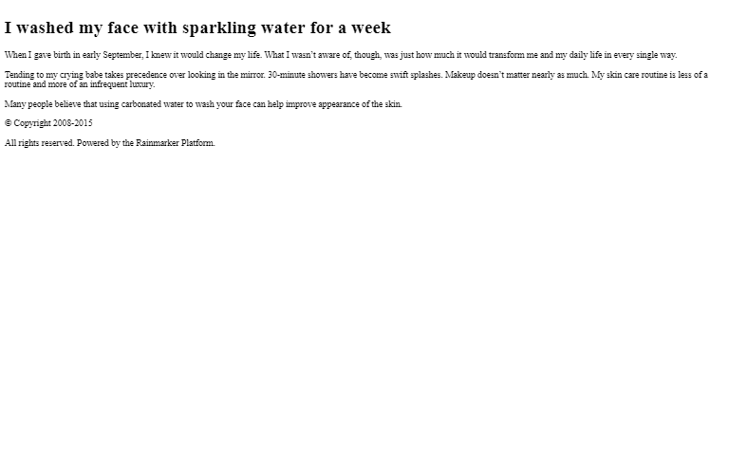

### Constraints

* The title should be "**Semantic Tags**"
* Add header tag for the header section
* Use h1 tag for the heading
* Add main tag for the main content
* Create two paragraphs inside (p tag)
* Use footer tag for the last section
* Create two paragraphs inside (p tag)

## Semantic Article Page

Create a web page like the following:

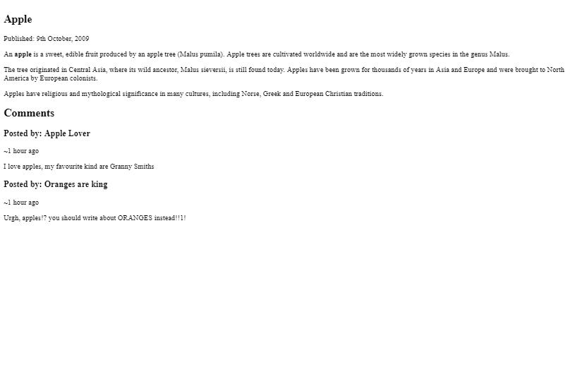

### Constraints

* The title should be "**Semantic Article Page**"
* Use article tag to create an article
  + The article has header with h1 heading and a **paragraph** for the published date inside
  + Use date tag for the date
* Use p tag to create 3 paragraphs after the **header**.
  + The paragraphs contain the article content *(info for apple)*
  + Use **b** tag where is needed
* Use section tag to create the "**Comment section**"
  + Add two headings (h2) and two articles inside (article)
  + Each article contains a comment and has:
  + **Header** with an **h3** heading and a **paragraph** for the time
  + Exactly one **paragraph** for the comment

## Semantic Blog Layout

Create a web page like the following:

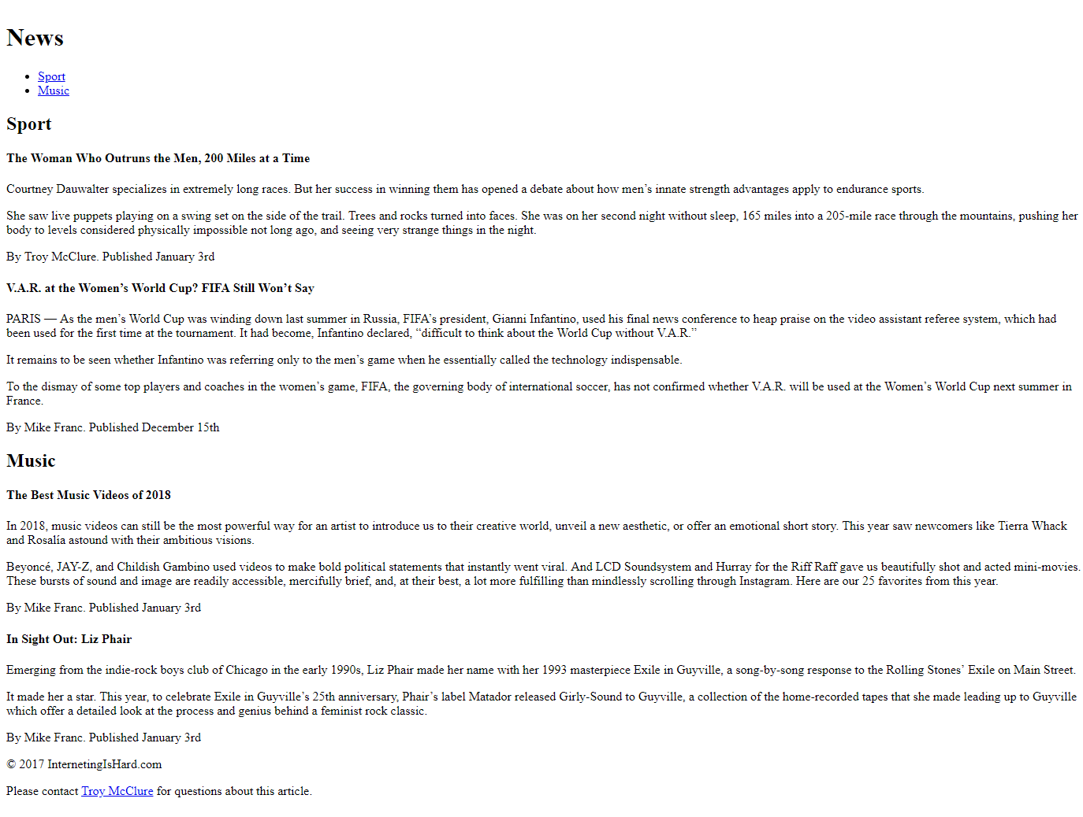

### Constraints

* The title should be "**Semantic Blog Layout**"
* Use header tag for the header section
  + Use h1 tag for the heading
  + Use nav tag for the navigation with an unordered list (ul) inside
* Create two **list** items with **anchor** (a) tags inside
* Use main tag for the page main content
* Create two **sections** in the main. Each section has:
  + A header with h2 heading
  + Two articles with h4 heading and three p tags inside
    - For the dates use time tag
  + Use footer tag with **two** paragraphs Inside
    - Use **anchor** tag for the name in the last sentence

## Semantic Tables

Create a web page like the following:

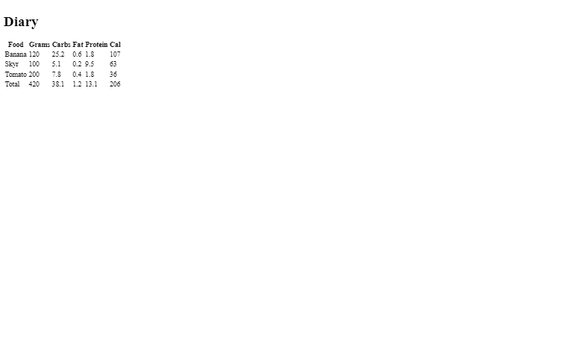

### Constraints

* The title should be "**Semantic Tables**"
* Use h1 tag for the heading
* Use table tag to create a table
  + Use thead tag for table head
  + Use tbody tag for table body
  + Use tfoot tag for table footer
* Use tr tag for rows
* Use th and td tags for columns

## Tags Cardio - DataTable

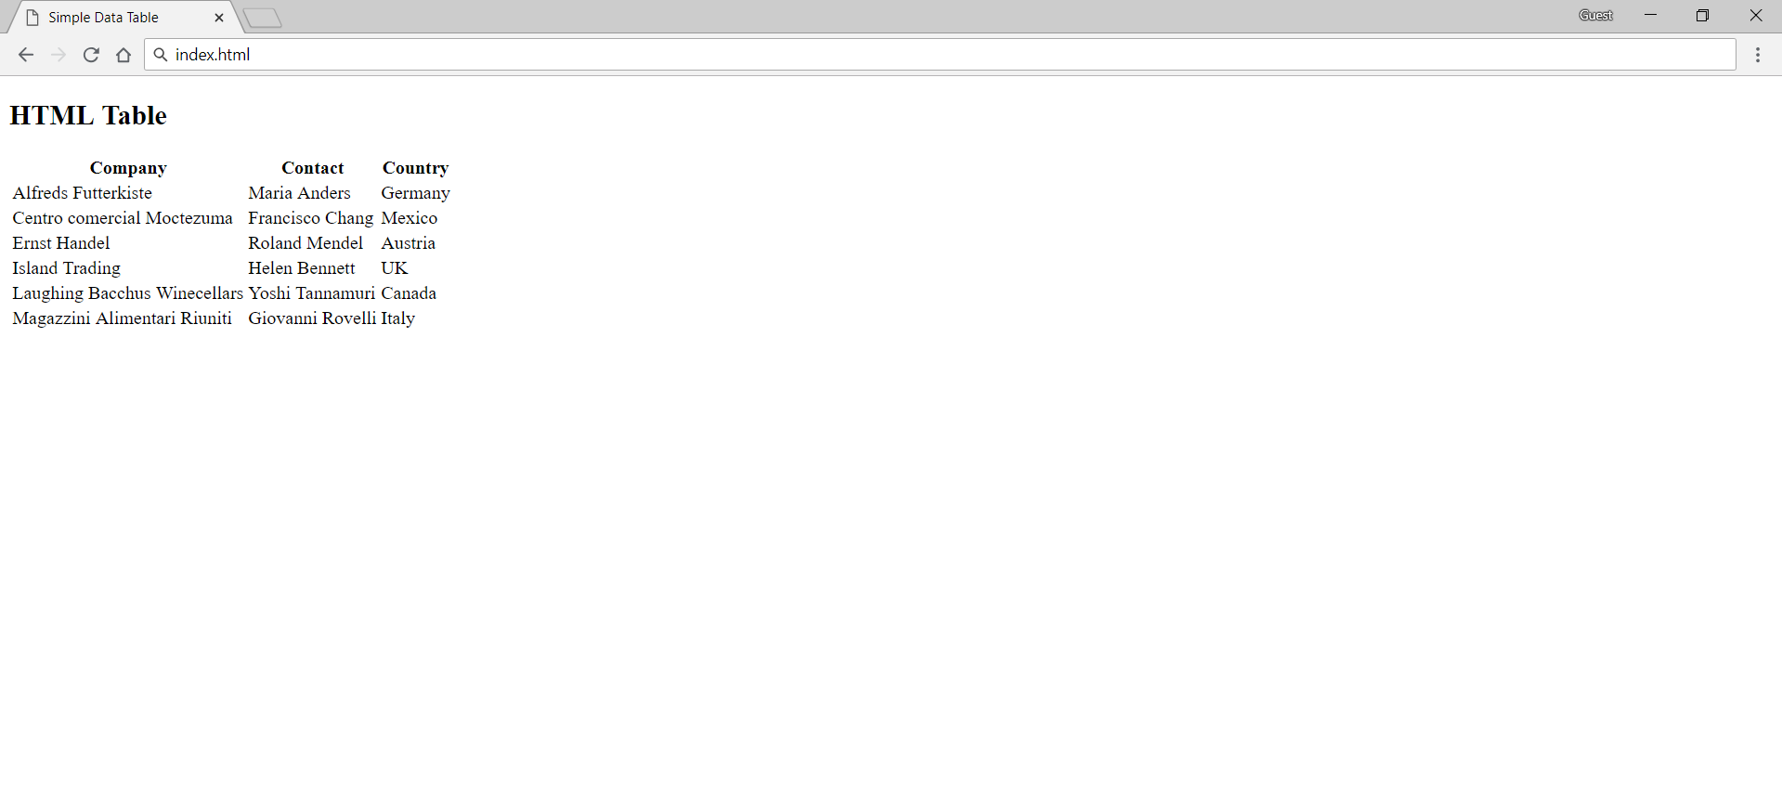

### Constraints

* Change the document **title** to "**Simple** **Data** **Table"**
* Use h2 tag for heading
* Use table, thead, and tbody tags to create table
* Use tr tag for rows
* Use th and td tags for columns

## Tags Cardio - Forms

Create a web page like the following:

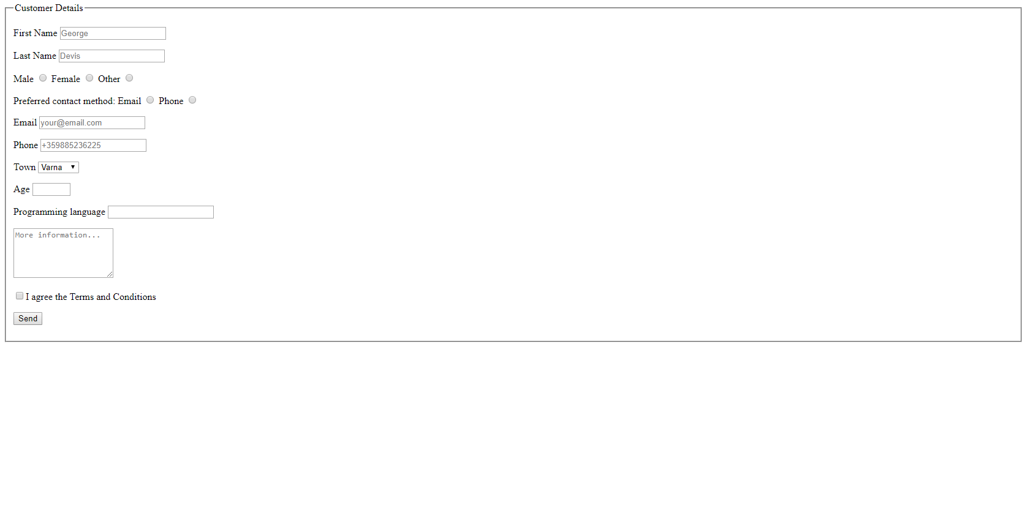

### Constraints

* Change the document **title** to "**Forms"**
* Use a formtag
* Use a fieldset tag with legend - "**Customer** **Details**"
* Each input tag should be in label:
* The **[**First Name**]** input field must be focused
* The **[**Email**]** input tag should have type="email"
* The 3rd and the 4th labels should contain input tags with type="radio"
* The 7th label should have select tag and option tags with the city name values
* The 8th label should have input tag with type="number" (with **min value** - 18 and **max value** - 70)
* The 9th label should have datalist tag and option tags with the languages type value
* The 10th label should have textarea tag with **5 rows** and **20 columns**
* The 11th label should have input tag with type="checkbox" and value "checked"
* The 12th label should have input tag with type="submit"
* The placeholders are obligatory

## Clean Up Baby Magazine

Open <https://www.babycaremag.com/> and copy the HTML code of the website. Open the copied code in your IDE and clean it up.

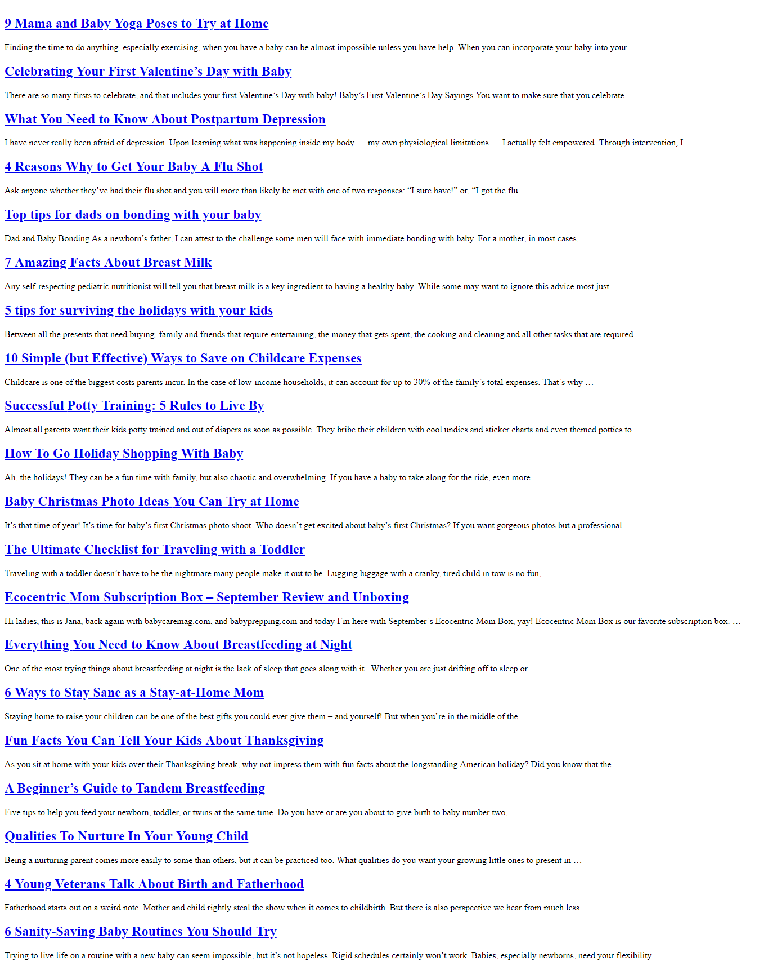

### Constraints

* Remove all link, script and meta tags
* Leave only the title in the head **tag**
* Clean up all **CSS**
* Remove all div, table, tbody, tr, th, td, ul, ol, li**,** span, label, dl, dd tags
* Leave only **headings** and p tags in the body
  + Remove all class, id, style attributes in headings and paragraphs
  + Remove all img tags from paragraphs
  + Leave only the text and a tags in the paragraphs
* Remove title, class attributes from the a tags
* Only **articles** should remain in your HTML file. Each article must have:
  + A h2 tag with a tag inside with the article title
  + A **paragraph** with the article text
  + You must delete everything else in the body tag

### Hints:

To download the HTML code, click Ctrl+S and save the files.

## Clean Up - Magazine

Open <https://foodandtravel.com/> and copy the HTML code of the website. Open the copied code in your IDE and clean it up.

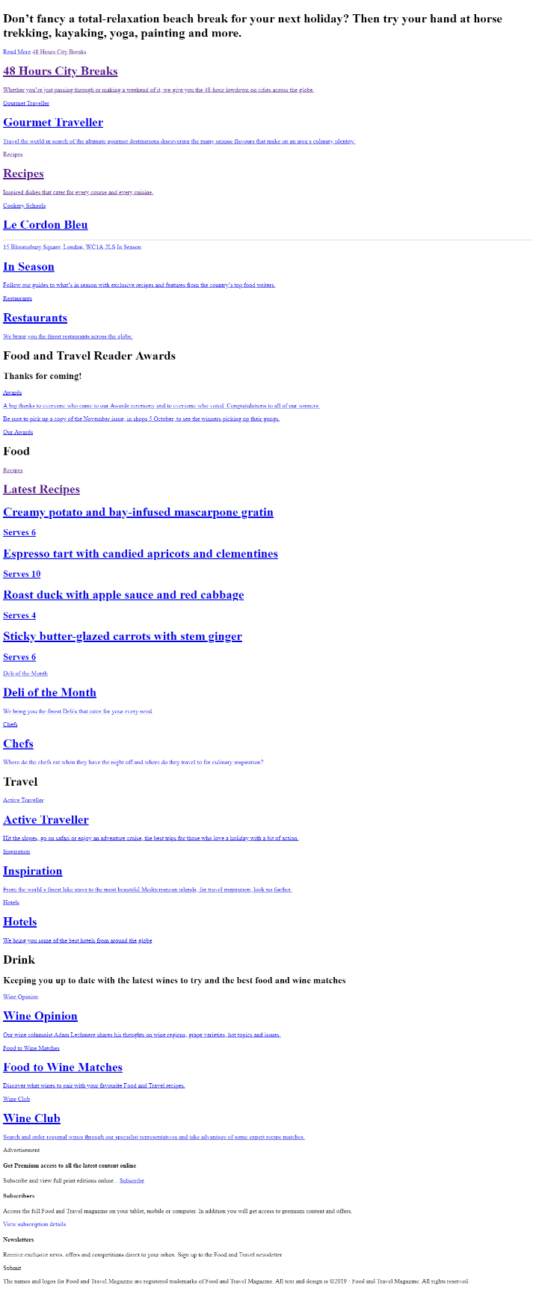

### Constraints

* Remove all link, script and meta tags
* Leave only the title at the head
* Clean up all **CSS**
* Remove all div, table, tbody, tr, th, td, ul, ol, li, span, label, dl, dd tags
* Leave only **headings** and p tags in the body
  + Remove all class, id, style attributes in headings and paragraphs
  + Remove all img tags from paragraphs
  + Leave only the **text** and the a tags in the paragraphs
* Remove title, class attributes from the a tags
* The first text on your page must be the title **"**Don't fancy a total-relaxation...**"**

### Hints:

To download the HTML code, click Ctrl+S and save the files

## Clean Up - Wiki Elephant

Open <https://en.wikipedia.org/wiki/Elephant> and copy the HTML code of the website. Open the copied code in your IDE and clean it up.

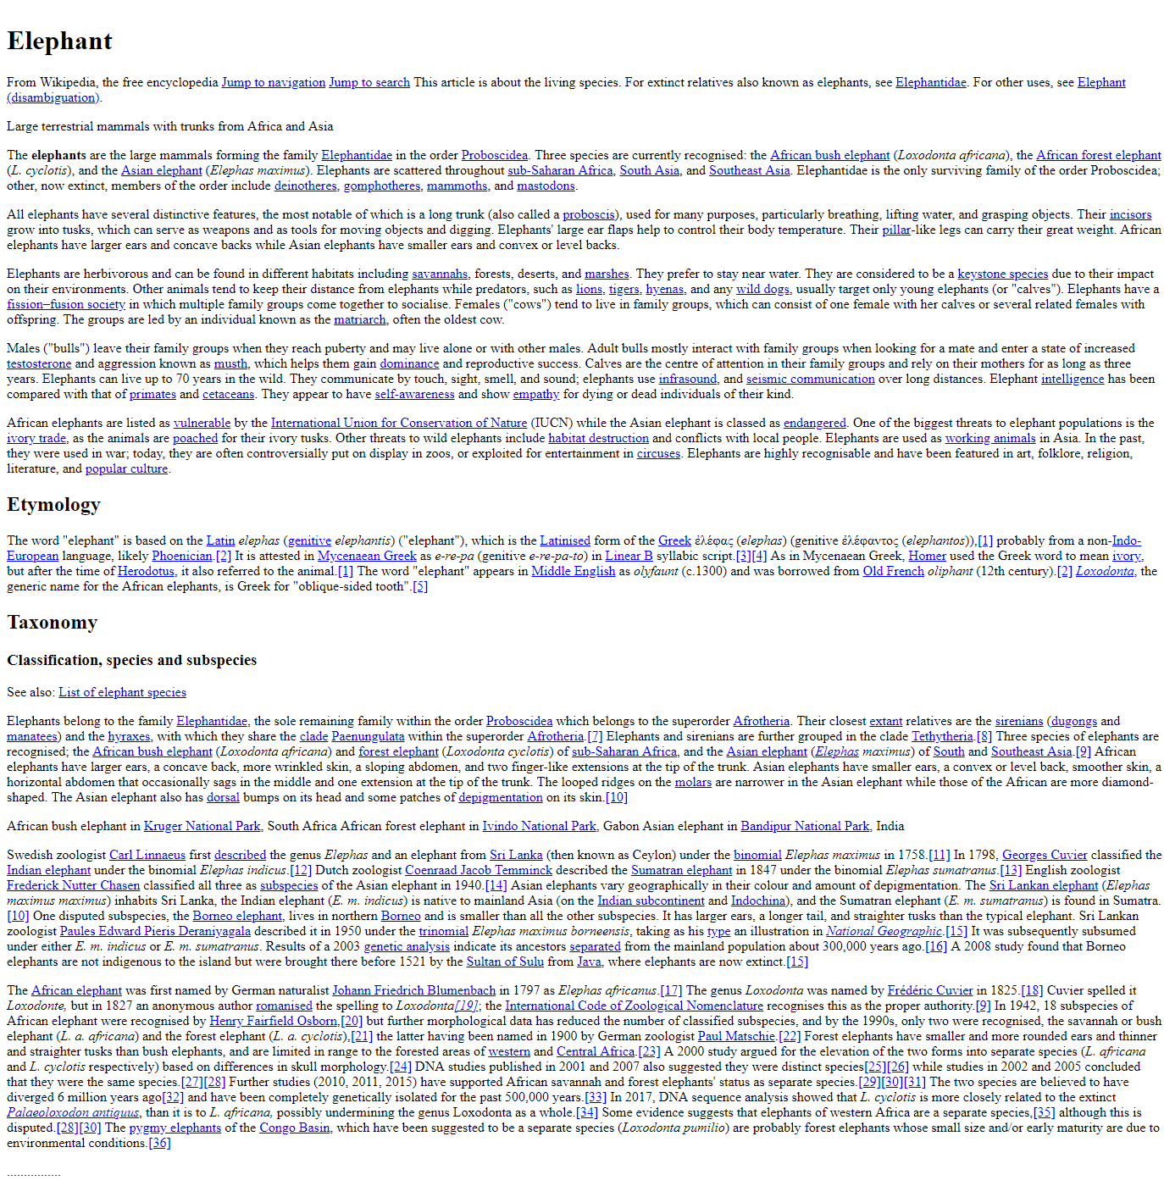

### Constraints

* Remove all link, script and meta tags
* Leave only the title at the head
* Clean up all **styles (CSS)**
* Remove all div, table, tbody, tr, th, td, ul, ol, li, span, label, dl, dd tags
* Leave only **headings** and p tags in the body
  + Remove all class, id, style attributes in headings and paragraphs
  + Remove all img tags from paragraphs
  + Leave only the **text** and the a tags in the paragraphs
* Remove title, class attributes from the a tags

## Clean Up - Wiki Bulgaria

Open <https://en.wikipedia.org/wiki/Bulgaria> and copy the HTML code of the website. Open the copied code in your IDE and clean it up.

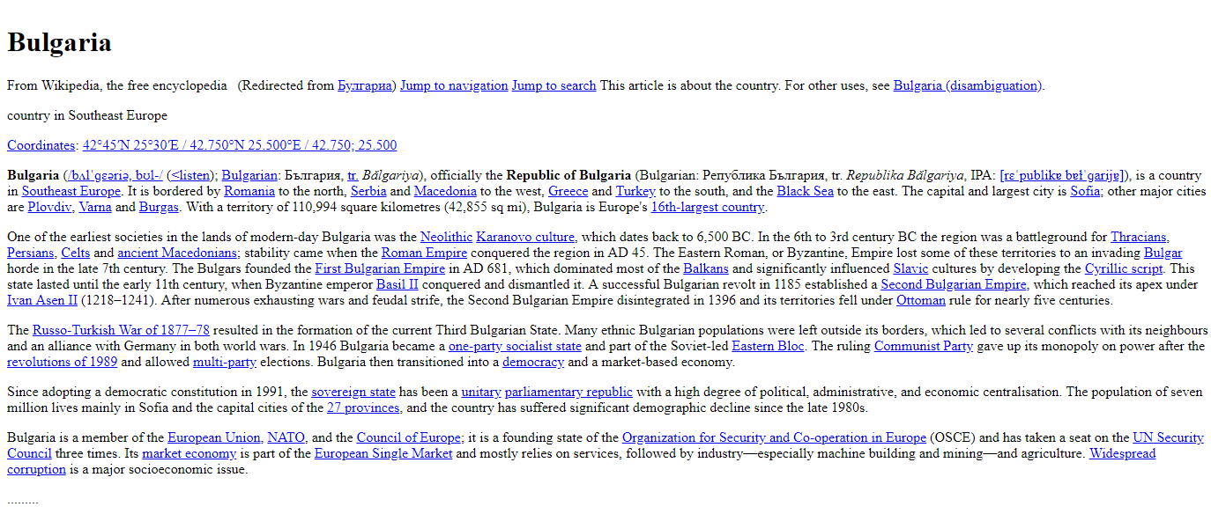

### Constraints

* Remove all link, script and meta tags
* Leave only the title at the head
* Clean up all **styles (CSS)**
* Remove all div, table, tbody, tr, th, td, ul, ol, li, span, label, dl, dd tags
* Leave only **headings** and p tags in the body
  + Remove all class, id, style attributes in headings and paragraphs
  + Remove all img tags from paragraphs
  + Leave only the **text** and the a tags in the paragraphs
* Remove title, class attributes from the a tags
* Delete everything under the text with title "**Sports"**